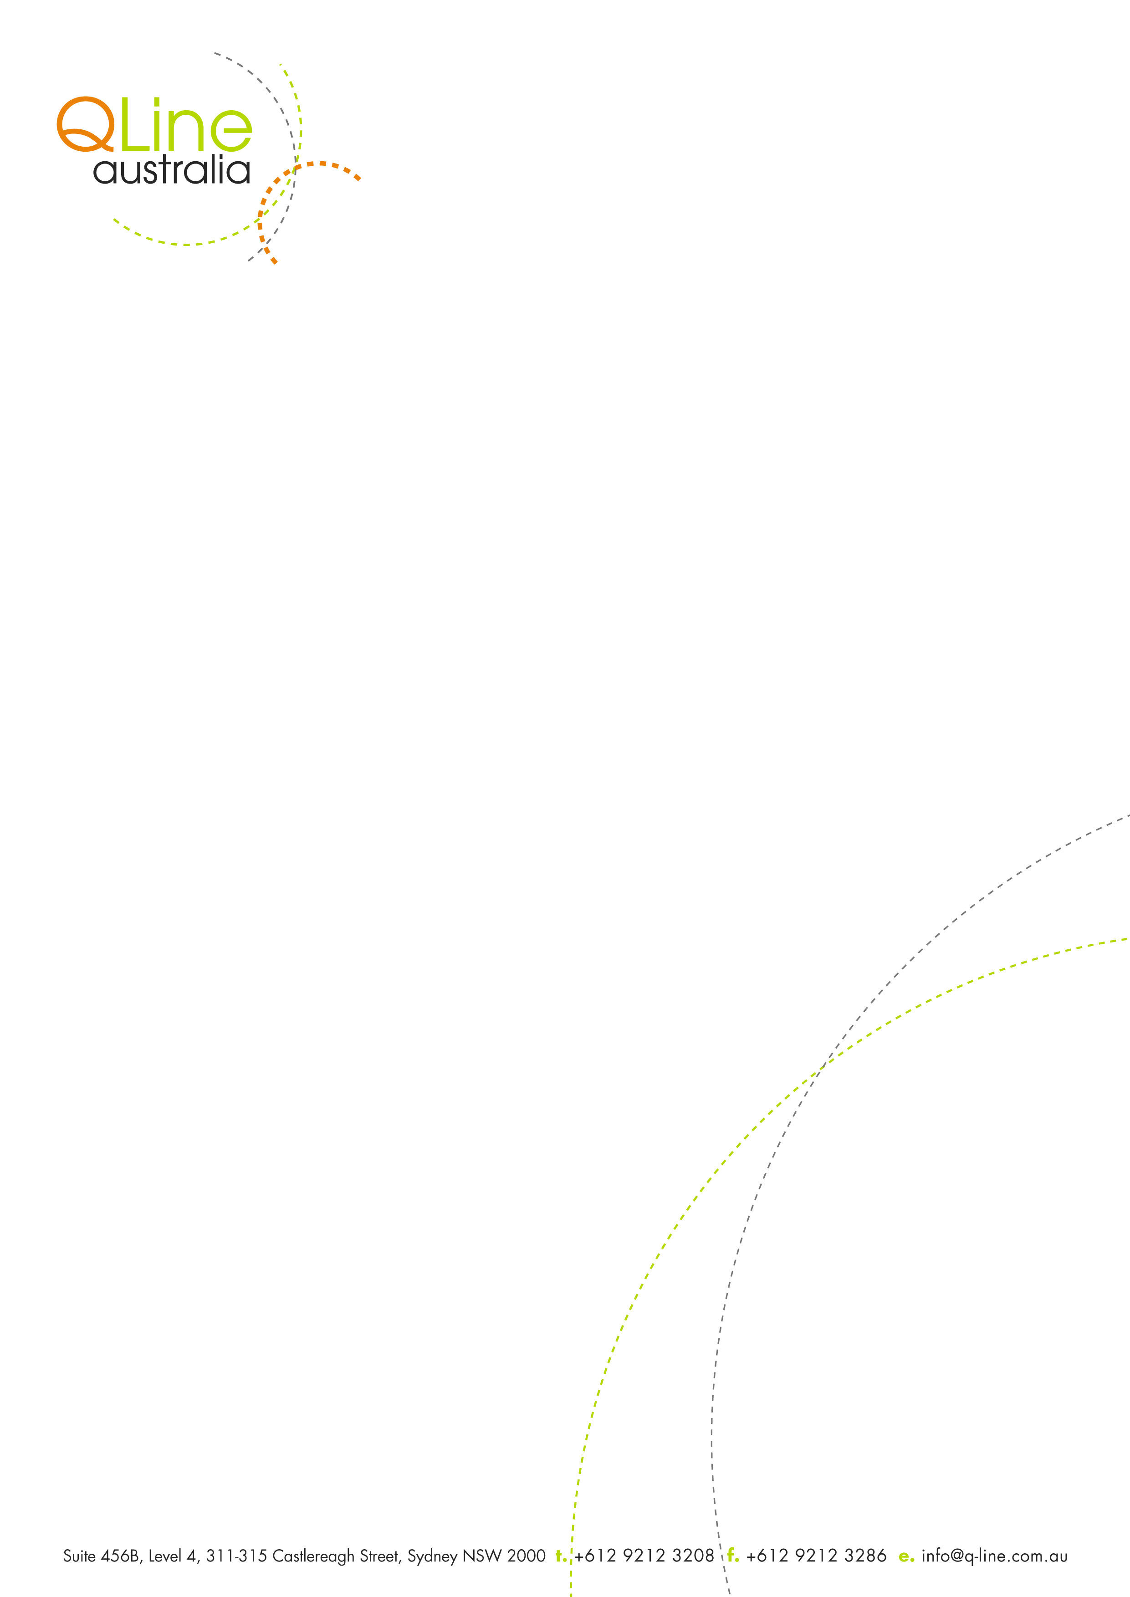
CLIENT ACCOUNT APPLICATION

I/We apply to Q-Line Australia to open an account. Q-Line Australia states as QLA from below.
I/We understand that the credit terms are strictly 30 days from invoice date. Duty & Gst charges are excluded from the credit term. Credit terms of QLA are subject to change based on prevailing market conditions. Any changes, however, will be communicated in writing prior to implementation. If credit terms are not adhered to, QLA reserves the right to charge on the monies owing at 2.5% per month. I/We understand that we are liable to pay all expenses, interest and legal costs incurred by QLA as a result of our default.
If QLA considers it relevant to assessing my/our application for commercial credit, I/we agree to QLA obtaining from a credit reporting agency a credit report containing personal credit information about me/us in relation to commercial credit provided by QLA. I/We agree to QLA obtaining personal information about me/us from other credit providers, whose names I/we may have provided for QLA or that may be named in a credit report, for the purpose of assessing my/our application for commercial credit, made to the Company.

I/We disclose the following information and undertake that it is true and correct.
Client Company Name/Business Name: ABN:

Trading Name: Telephone: Fax::

Trading Address:

If Company is a subsidiary, name of Parent Company:

Nature of Business:

Date of Commencement: Number of Employees:
Full name and private address of Directors, Proprietors and Partners
1.
2.
3.

Credit Account up to a Limit of $
Trade References: (Not banks, building societies)
1. Telephone:

2. Telephone:

3. Telephone:
We authorize Q-Line Australia to obtain information from these Trade References and a credit report from any credit reporting agency for the purpose of assessing our application for commercial credit.
ACCEPTANCE OF CONDITIONS
We apply to open an account with QLA for business purposes only. We acknowledge that we have read and agree to be bound by the Conditions overleaf and attached and that these Conditions apply to the provision of any and all Services provided to us by QLA. We acknowledge and warrant that the person signing this Application on our behalf is duly authorized to do so and that the use of our own forms or documentation does not in any way modify, amend, vary or derogate from these Conditions
Name: Title:

Signed: Date:

ABN: 46 116 759 490

